***Assignment:5***

* **Problem statement:** Create a public bucket in AWS. Upload a file and checked by reassigned URL whether you can access the file or not
* **Steps:**

1. Signup to the AWS account and click on S3 tab

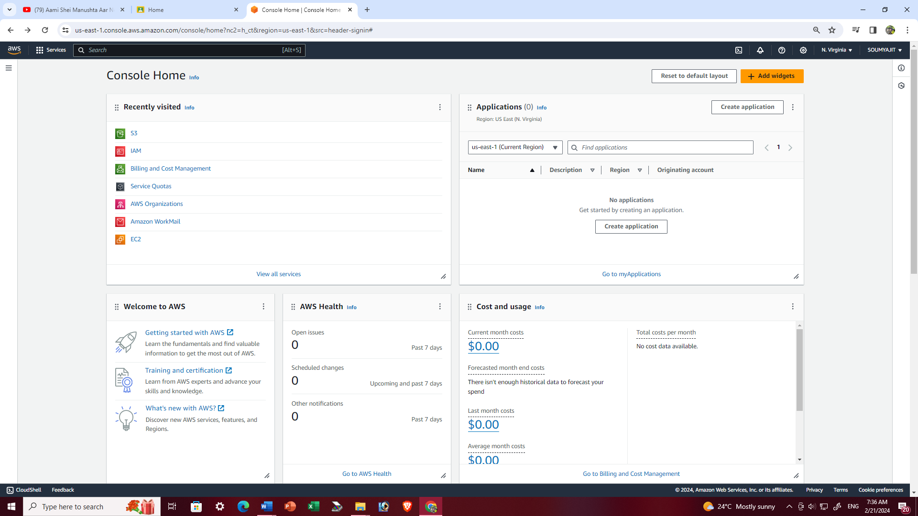

1. Click on the “create bucket option”

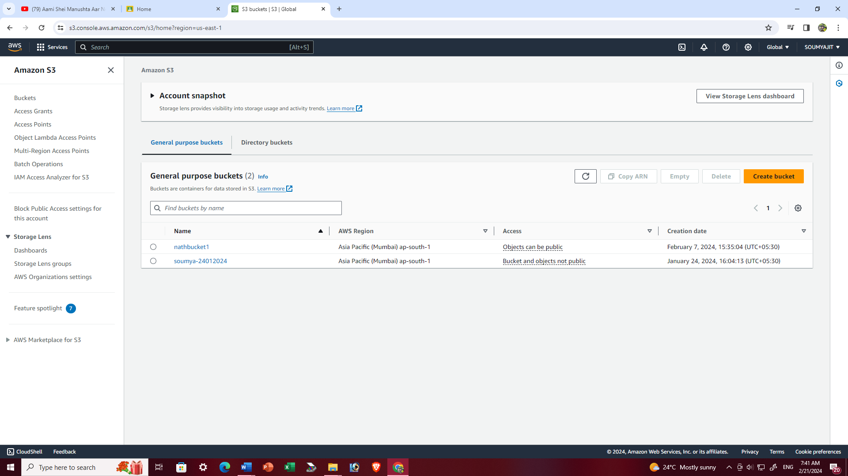

1. Fill up the required details->’AWS region’ , ‘Bucket name’ then we have to do ‘ALC enabled’ because we are creating a private bucket and check the other configuration as per the snapshots then click on ‘Create bucket’.

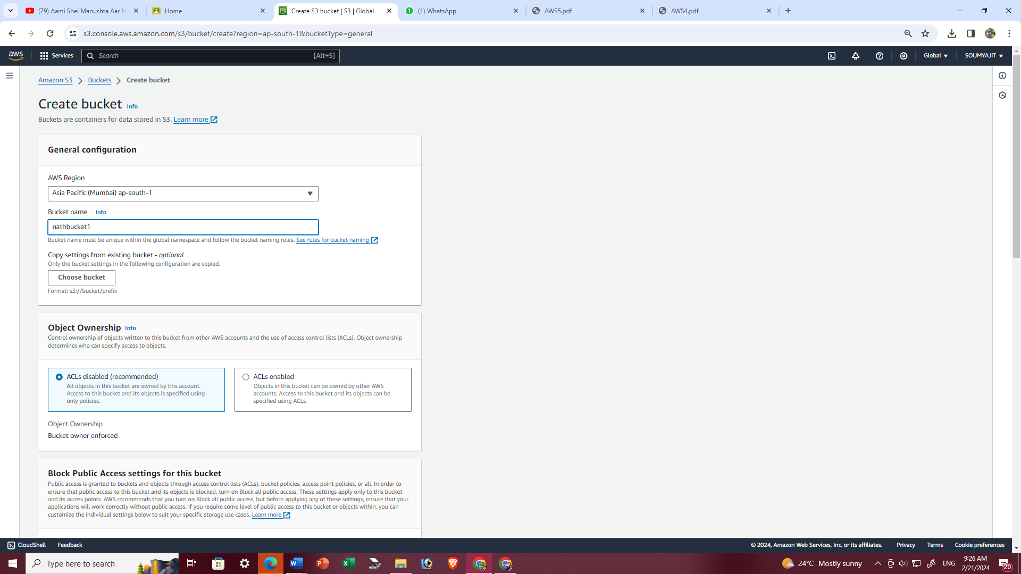

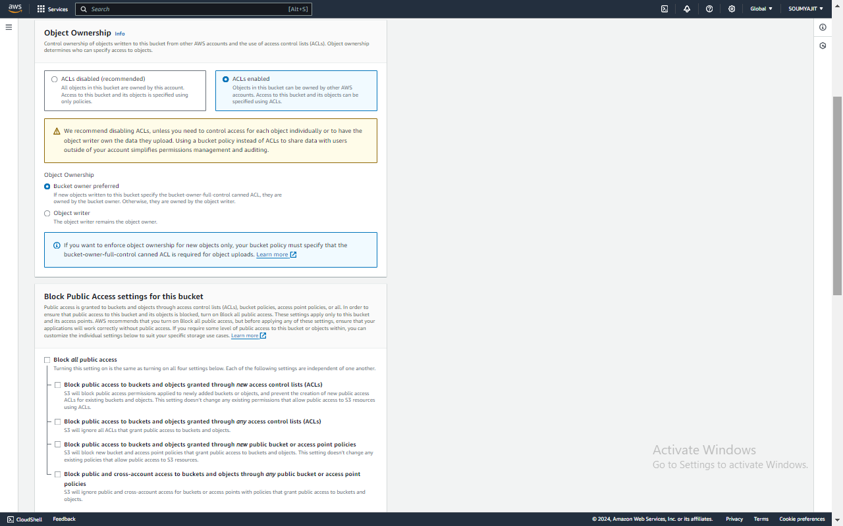

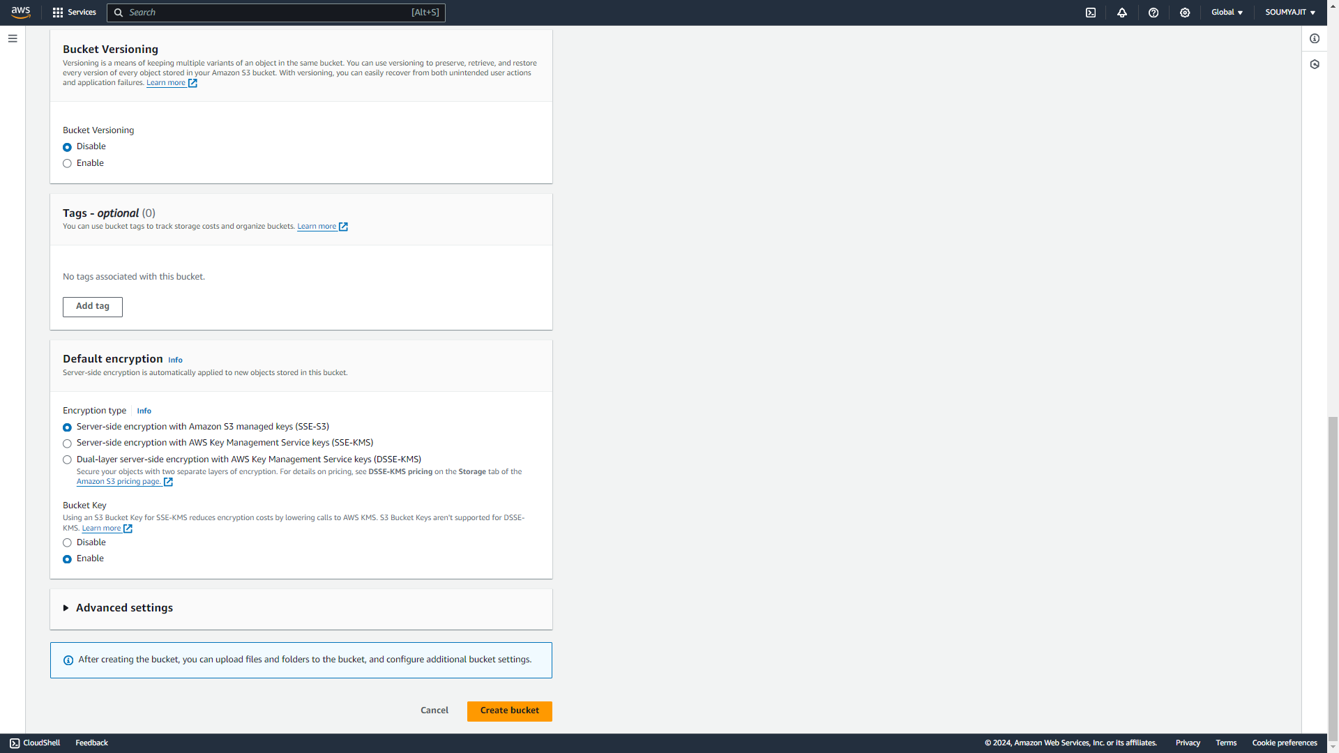

1. ‘nathbucket1’ bucket is created successfully then click on bucket name ‘nathbucket1’

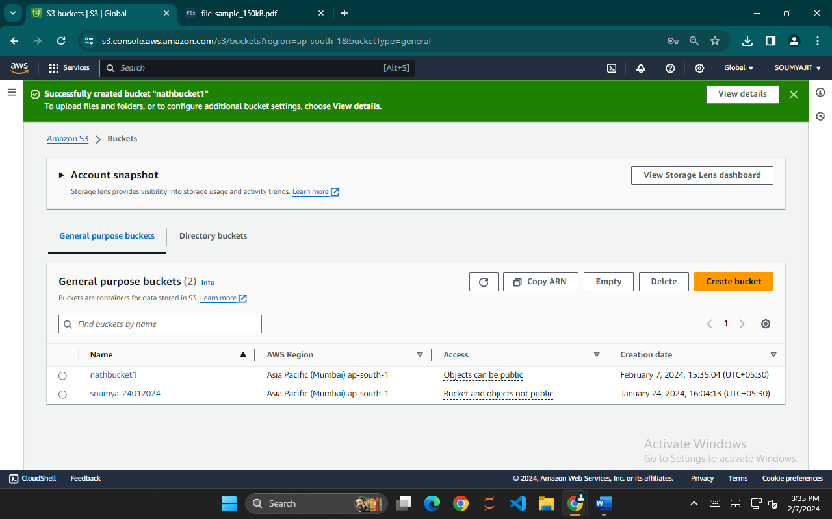

1. Under ‘nathbucket1’ click on ‘Upload’ then choose a file of your choice for uploading

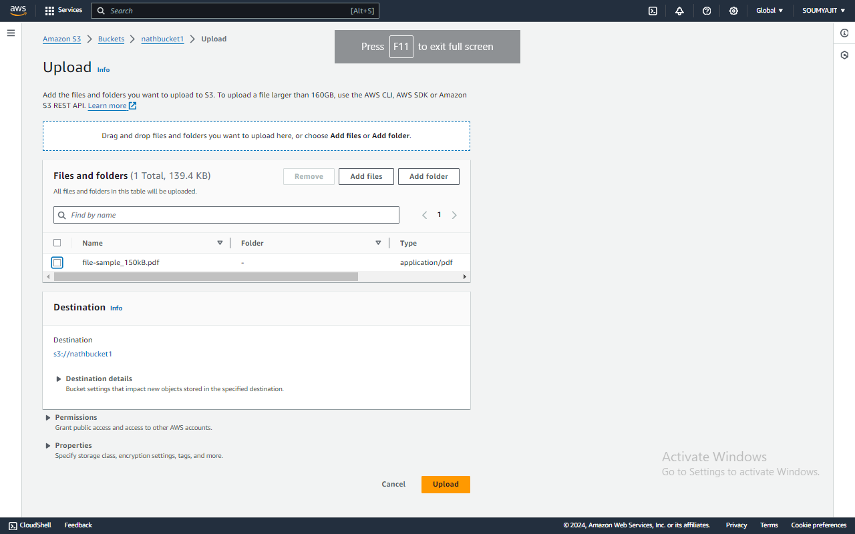

1. File is uploaded successfully , tap on ‘Close’ and click on ‘Name’.

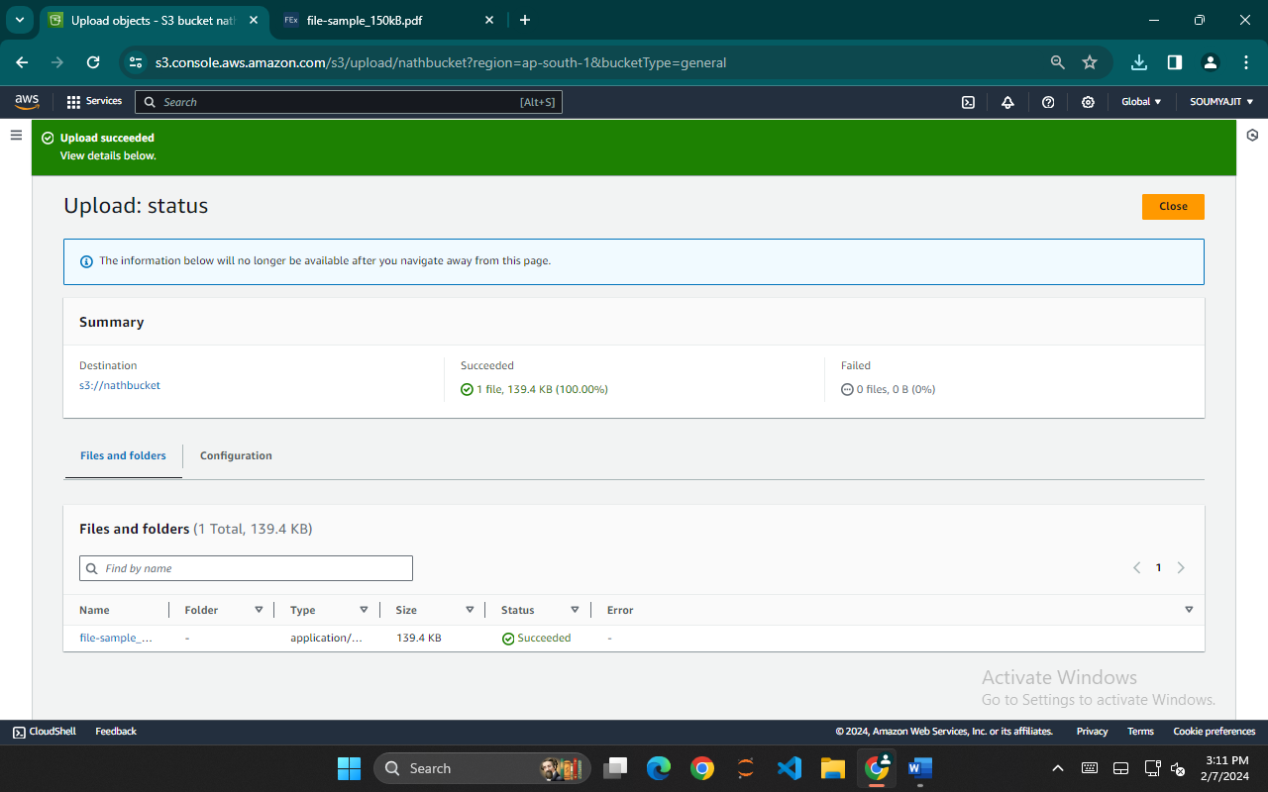

1. Under ‘Name’ tick off any one of the files(checkbox) and click on that file.

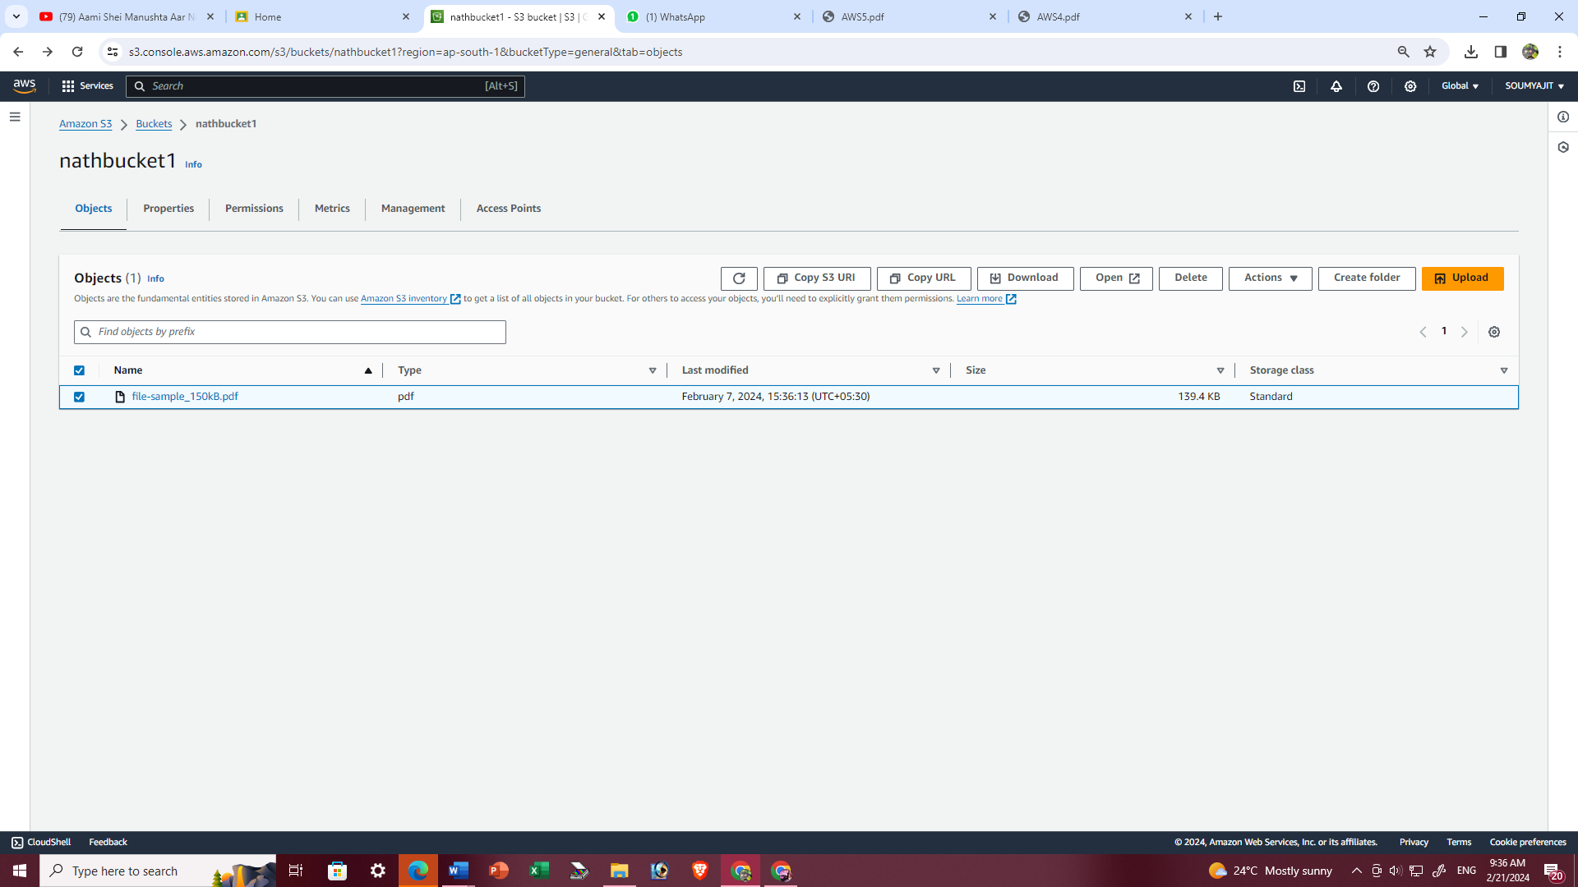

1. Copy the object URL and paste it into the Igcognito

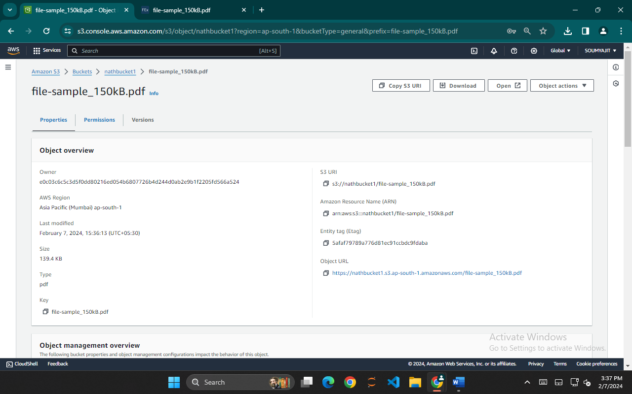

We will see that the file cannot be accessed.

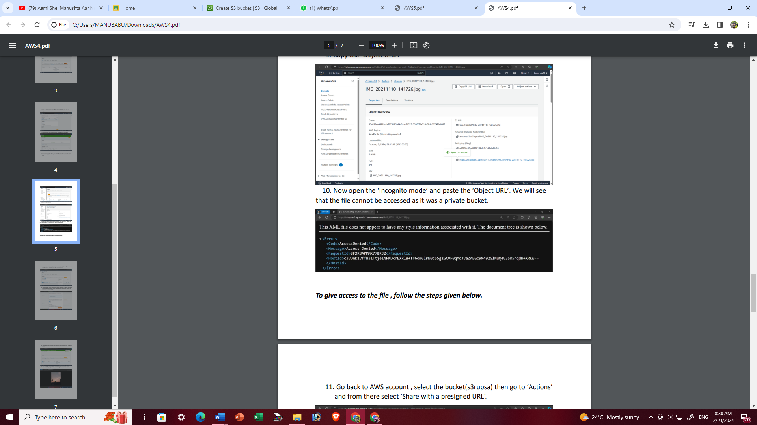

1. For the permission in the file info. click on ‘Permissions’ and then click on ‘Edit’ beside ‘Access control list(ACL)

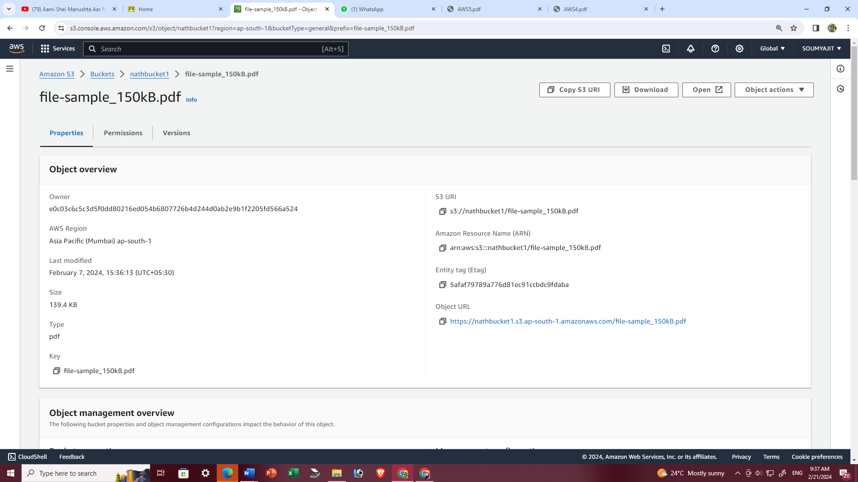

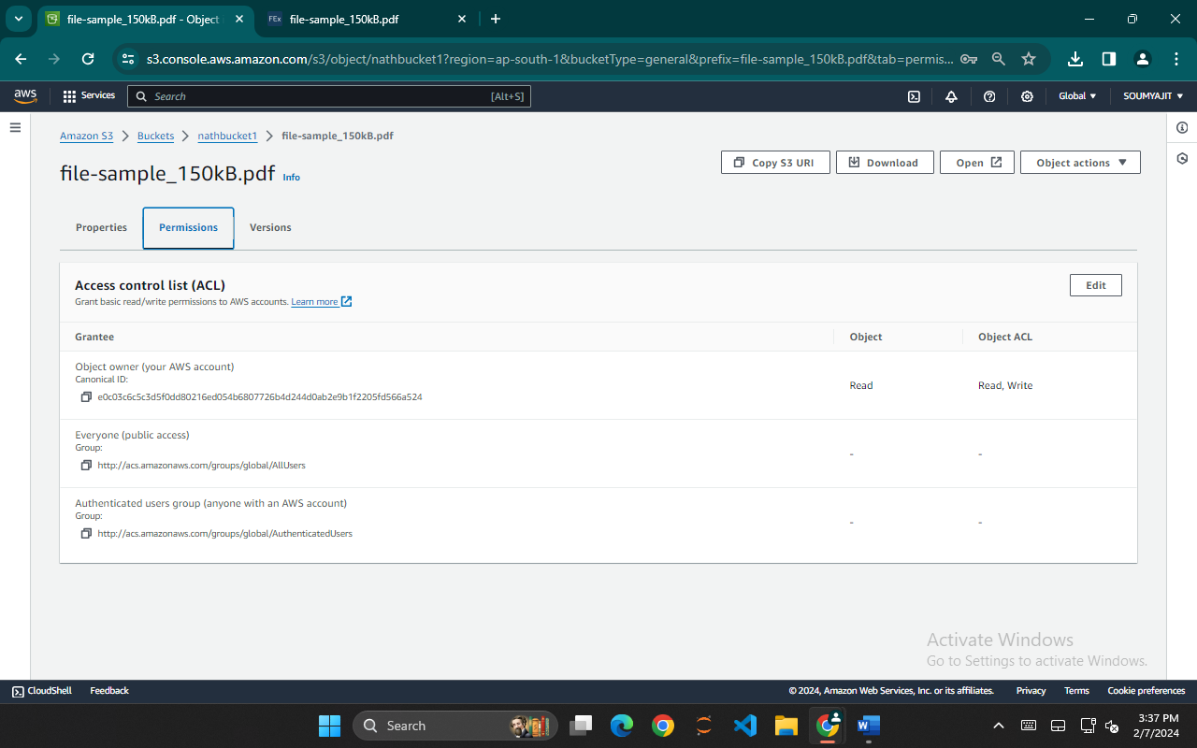

1. Now, tick off the Read checkboxes of ‘Everyone(public access)’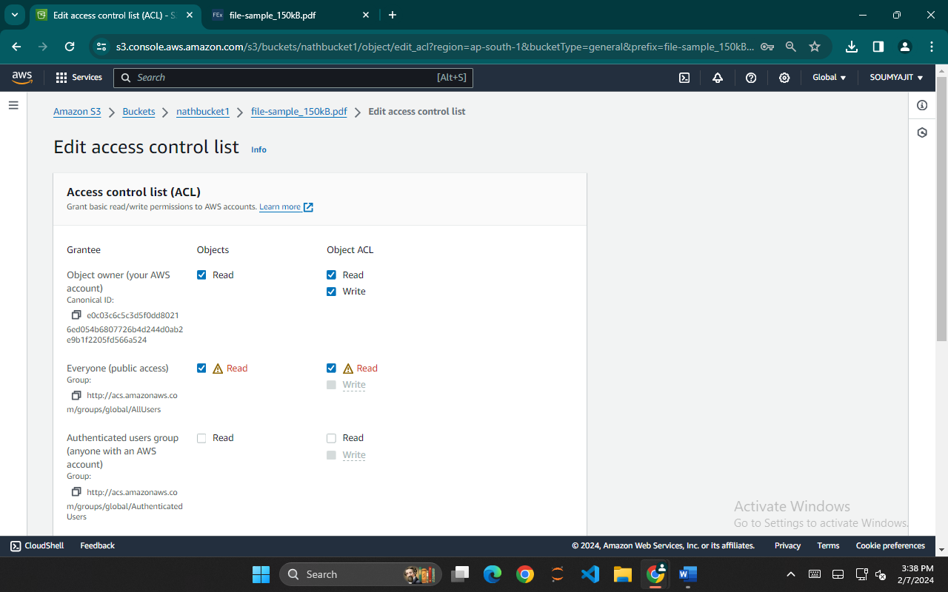
2. then tick off the checkbox ‘I understand….’ and click on ‘Save changes’.

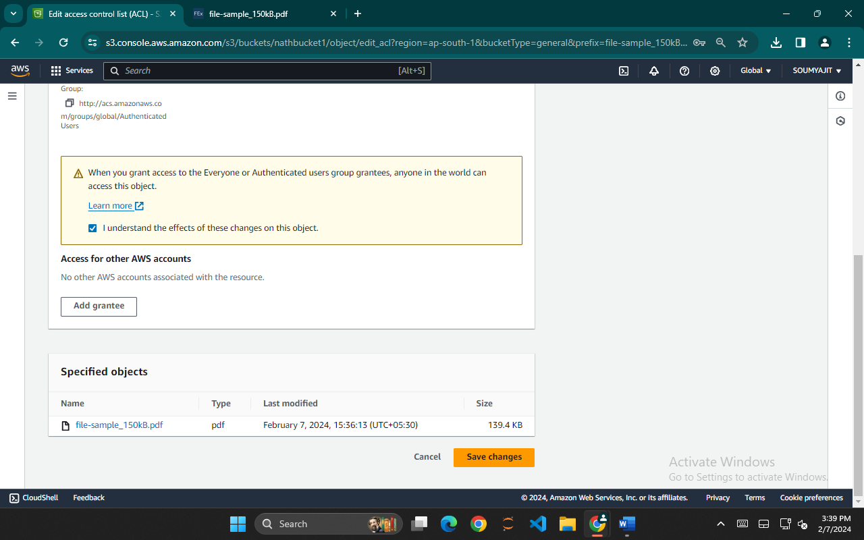

1. Now, again copy the Object URL.



1. In the ‘Incognito mode’, paste the Object URL. We find that now the file can be accessed publicly.